Provider Guide to Video Visits

GETTING STARTED – AT LEAST 1 DAY BEFORE YOUR FIRST VISIT
- Zoom Account:
One of the programs for telemedicine that is HIPPA compliant that we recommend is Zoom Video conferencing platform for Video Visits.

How to obtain a Zoom account:
- Create a Zoom account by going to https://zoom.us/signup
- Sign up with email

- Equipment and Software:
Equipment to use
- You can use any device with a camera, ie laptop or smartphone.
- Strongly advise using a laptop computer (PC or Mac) for video visits with patients. (If using smartphone, download smartphone app instead of desktop app)

Best practice tip: to be able to share images during the video visit (using Zoom), use a computer (PC or Mac) where the images can be accessed

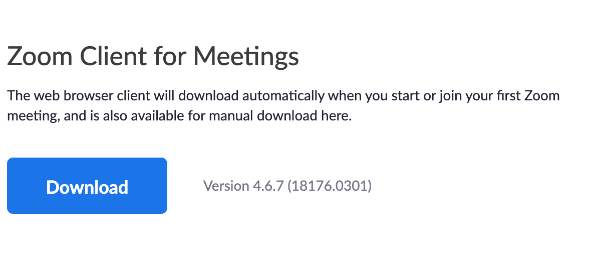
Installing the Zoom software:
- Install the software on the computer or device you will use for video visits.
- Go to https://zoom.us/download
- Click download, open the folder when complete.
- Install Zoom.

- Considerations
Things to think about before conducting your visits
- Location: video visits can be conducted from any appropriately private and professional space. Make sure the background is clean, the environment is quiet, and zoom software is installed on the device.

CONDUCTING YOUR FIRST VISIT
- Open Zoom app on your chosen device
- Open the desktop app on your laptop (preferred) or smartphone

- You must be signed into Zoom to properly host the meeting
If prompted to sign in:
- Sign in using email address and password

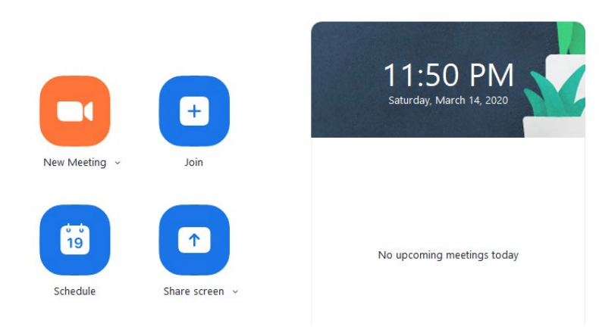
- Start a meeting
- Click the “New Meeting” button to start your Personal Meeting.

NOTE: administrative staff in your practice can give your Personal Meeting ID to the patient ahead of time. You can also provide the patient with the meeting ID over the phone at the time of your visit.

- Ensure that you can see yourself on the screen and that you have joined the audio.
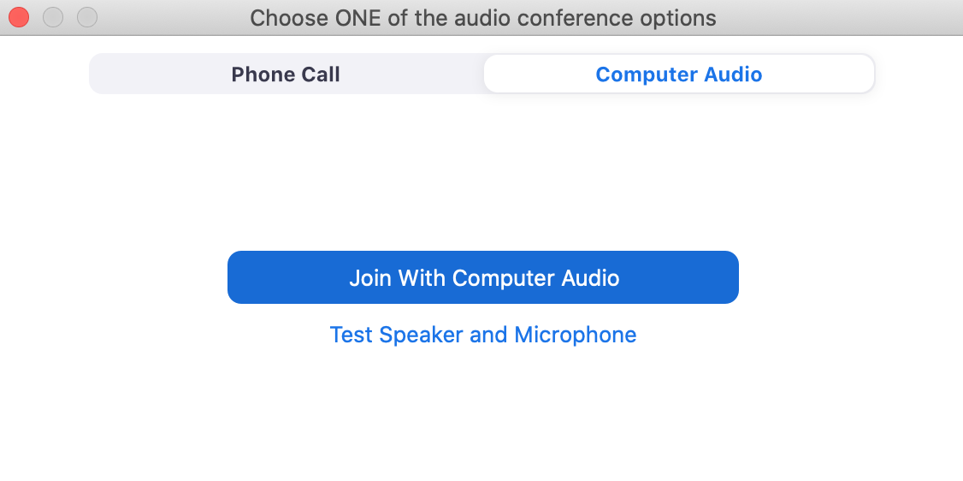
- If you can’t see yourself on the screen, click Start video
- Have you Provider ID badge fully visible during the visit
- Join with Computer Audio is recommended
  - Test your speaker and microphone to make sure they are working properly

- Interpreter Services
If you need an interpreter on the call:
  - Call your clinic’s interpreter services using your smartphone. When you are connected to an interpreter, let them know they will be on a brief hold and then add the Zoom meeting onto your call using your phone’s conferencing feature.

  - Phone conferencing feature varies by phone model. You will need to check how to do this based on the phone model you have.
- iPhone conferencing instructions
- Android conferencing instructions

How to conference in
  - When the interpreter is on the line, add a new call to the line.
  - Click on the carrot next to “Audio” click “Switch to Phone Audio”
  - Using your phone, dial into the first number listed. When prompted, enter the meeting ID, then press #. Do not enter a participant ID
  - Admit your phone to the meeting click Participants rename your phone to “interpreter”
  - To avoid echo, mute the audio on your mobile device
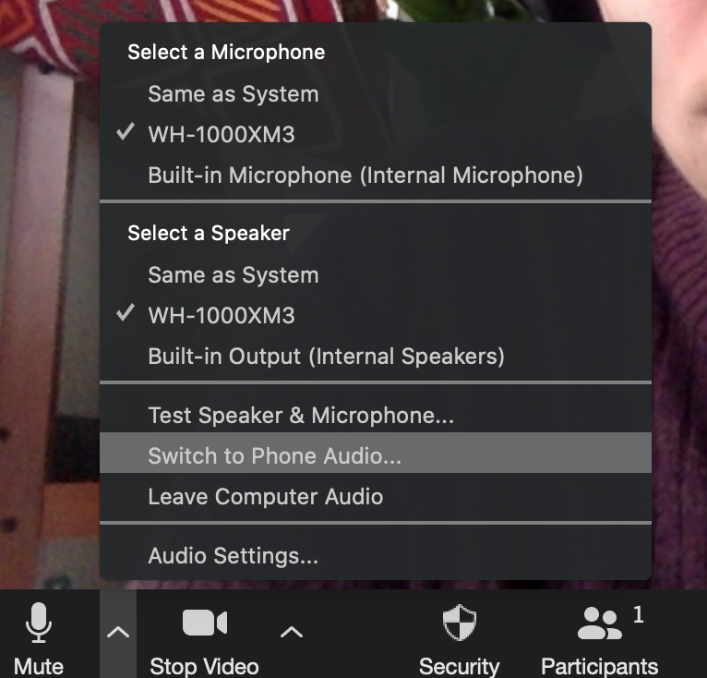
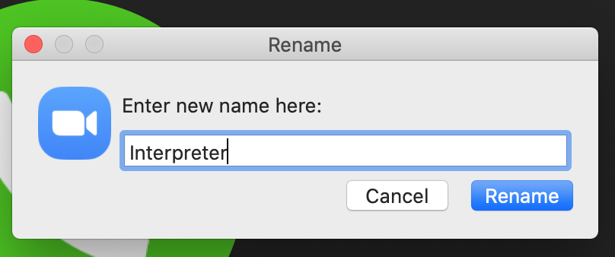
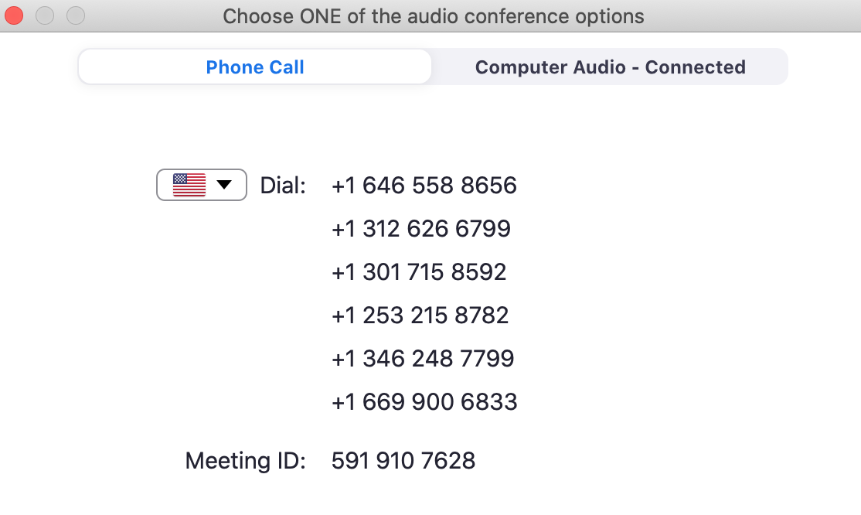

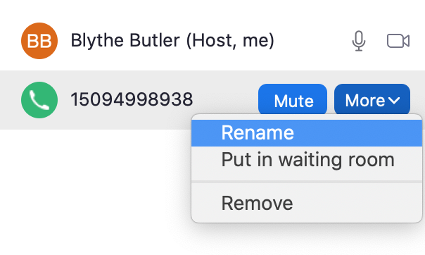

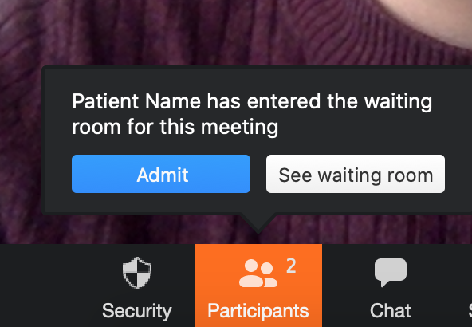
- Admit the patient to the visit
When a patient is in the waiting room, the “Participants” button will turn orange and you will see the option to admit them to the meeting.
- Click the “Admit” button in order to allow the patient to appear on screen

Helpful tips:
- If the Admit button is not visible, click “Participants.” The Waiting room will appear on the right of the screen.
- If you can’t see the patient, send the patient a prompt to turn on their video by clicking “Participants” More Ask to start video
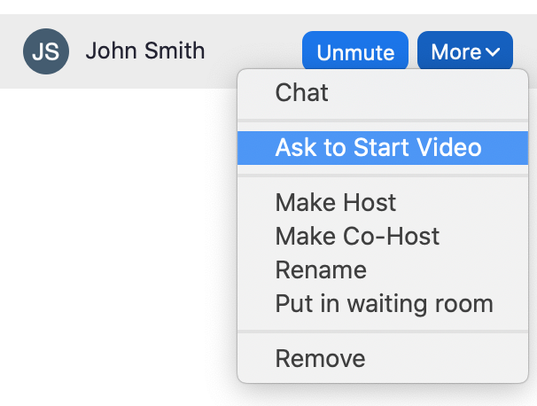
- If you can’t hear the patient, chat the patient and tell them to click “Join Audio”
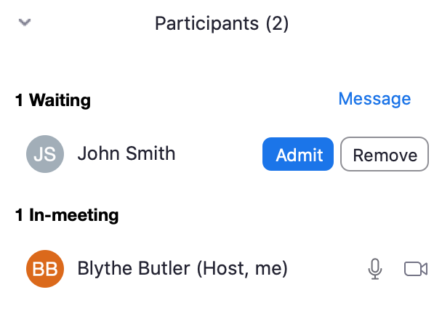

- Verify the patient’s identity (name and DOB)
- Ask for the patient’s consent to conduct their visit over video

- Conduct visit
Helpful tips:
- To share images or data, click “Share screen” button along the bottom of the Zoom window.

- If you are seeing patient’s arrive for later visits, they will stay in the waiting room until you admit them.
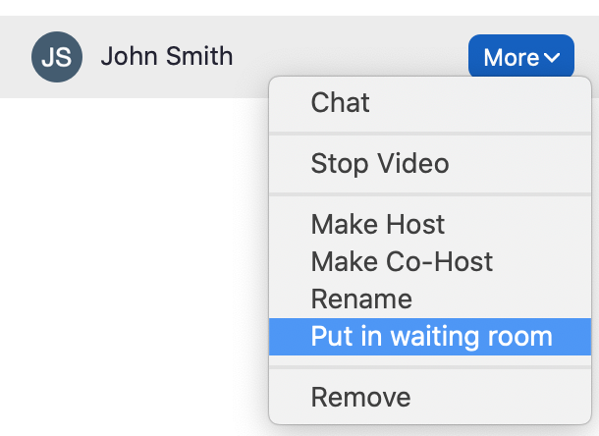
- If your patient doesn’t leave after their visit is over, place the patient back in the Waiting room before moving on to the next visit.
  - Click Manage participants More (next to the patient you’d like to move). Choose Put in Waiting room.

DOCUMENTATION/BILLING
- Document consent
- This documents that you have verbally confirmed the patient’s consent to a Telehealth visit and the patient’s location

- Visit type and billing
- At this time, the “video visit” visit type is not yet built for SFHN.
- Assign the video visit as a telephone visit and use a -95 modifier

- What to document
- Chief complaint
- Patient history
- Assessment and plan
- Names and roles of visit participants
- DO NOT document physical exam elements that require physically touching the patient!

- Sign the encounter

4 steps to a successful video visit:
- Download Zoom
- Log in to Zoom account. Ensure Personal Meeting ID and waiting room are selected in settings.
- Add an interpreter to the call using conference calling on your smartphone
- Ask for patient’s verbal consent upon starting Zoom video visit
- Document visit as normal without physical exam, and include consent for a video visit!

Questions or feedback on this tool? Please submit here: http://tiny.ucsf.edu/telemedsurvey

