Resident/Fellow Workflow for Video Visits
The following provides a workflow and step-by-step guidance for conducting video visits with residents

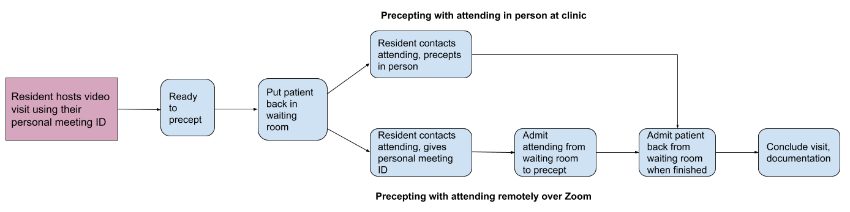
Workflow for Resident conducting video visit with Attending precepting:
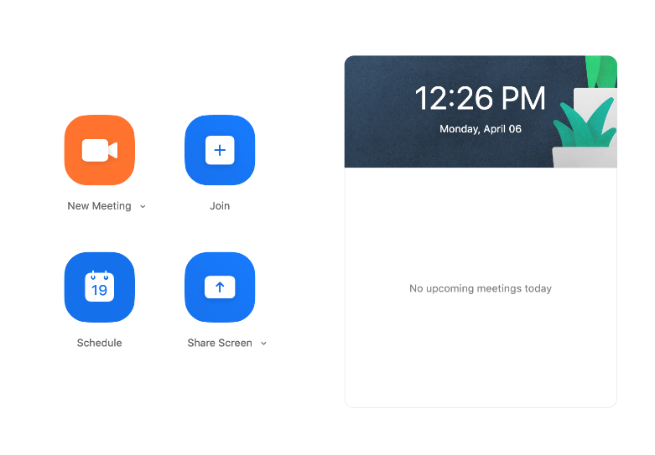
Step by step instructions:
- Resident/fellow host video visit using their own Personal Meeting ID
  - Open up Zoom desktop app
  - Click “New Meeting”
  - Admit the patient
  - Conduct the visit

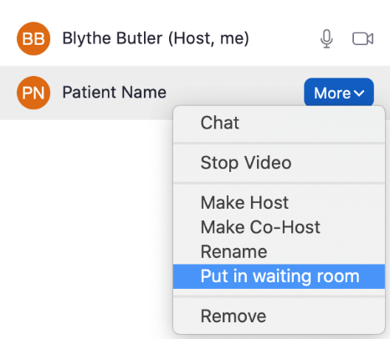
- When ready to precept visit, put patient back in Zoom waiting room
  - Click Manage Participants
  - Click More beside patient’s name
  - Click Put in waiting room

- Precept with attending (2 options)
  - Contact the attending via pre-determined method i.e. phone call, text, Voalte (whatever is easiest) to let them know you are ready

- Precept in person:
  - Precept in person as usual (both resident and attending in clinic)
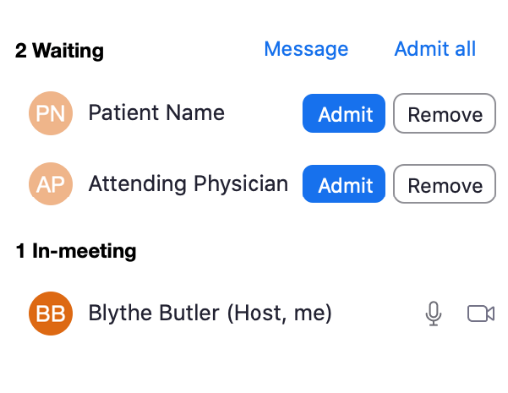
- Precept over Zoom
  - Give attending your Personal Meeting ID/invitation URL
  - Admit attending from the waiting room

- Re-admit patient to visit
  - If precepting with attending in person, can go back and finish visit together over Zoom

- Documentation
  - Ensure that .videovisitconsent SmartPhrase is used

Questions or feedback on this tool? Please submit here: http://tiny.ucsf.edu/telemedsurvey
4/6/20

