How to add an audio interpreter in a Zoom video meeting
Using an interpreter can be difficult when conducting video visits. The following is a workflow and detailed list of steps for how to add an audio interpreter into a Zoom video visit.

What you will need to get started:
- Zoom account with personal meeting ID and waiting room enabled
- Device with Zoom app installed
- A phone with conference calling enabled
  - Feature depends on phone model. Below are instructions for:
    - iPhone
    - Android
  - If this is not enabled, call the interpreter and put them on speakerphone in front of your screen for you and the patient to hear

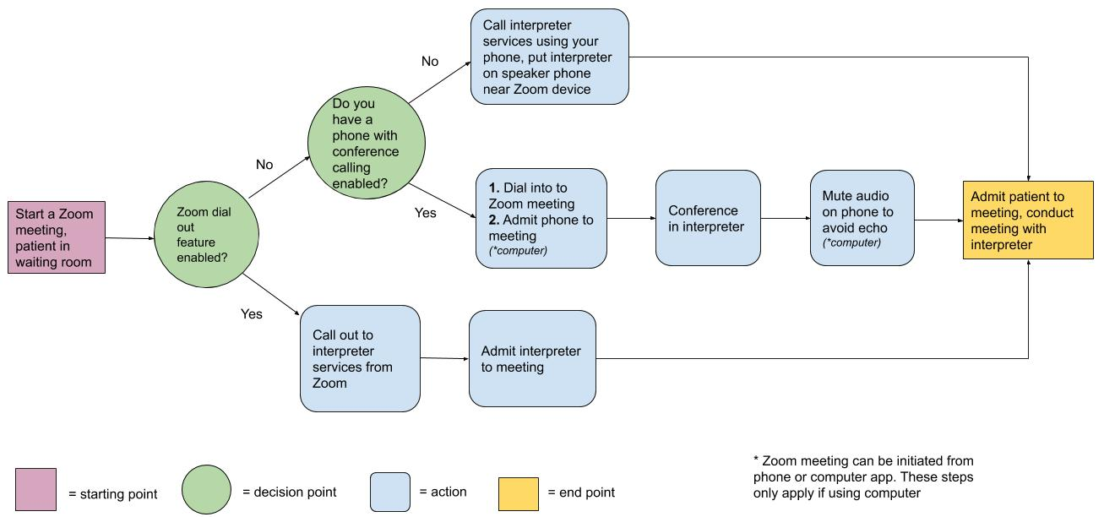
Summary of workflow

Step-by-step instructions:
When you are ready to begin a visit:
Launch a Zoom meeting
- Open Zoom app on your desktop
- Click “New Meeting” join with device audio

When the patient is in the waiting room:
** Business users can call interpreter directly from Zoom (if not available, skip this step)
- Once the Zoom meeting has been initiated, click Invite to send an invitation to the interpreter

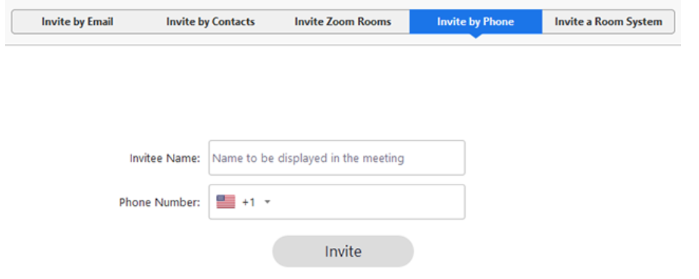
- Click Invite by phone option

- Enter the following on the Invite by phone screen:
  - Invitee name: Interpreter
  - Phone number: your clinic’s interpreter services line
- Click invite

- Admit interpreter into Zoom meeting
- Speak the name of the language that needs to be translated
- Introduce patient and yourself once interpreter arrives on the line

If you do not have this feature enabled, continue below:
*Note: If you are already connected to the Zoom meeting by phone audio (and not computer audio), skip to ‘”Conference interpreter services”⁺⁺

Call the Zoom phone number from your phone
- Find the Zoom phone number
  - If your Zoom is open on a computer:
    - On the bottom left of your computer screen, click on the carrot next to “Audio” click “Switch to phone audio”
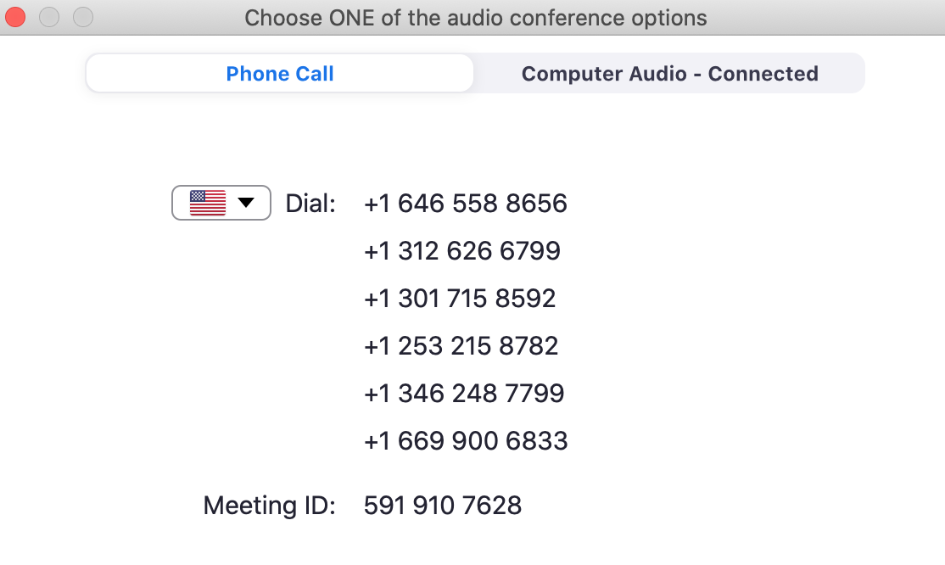
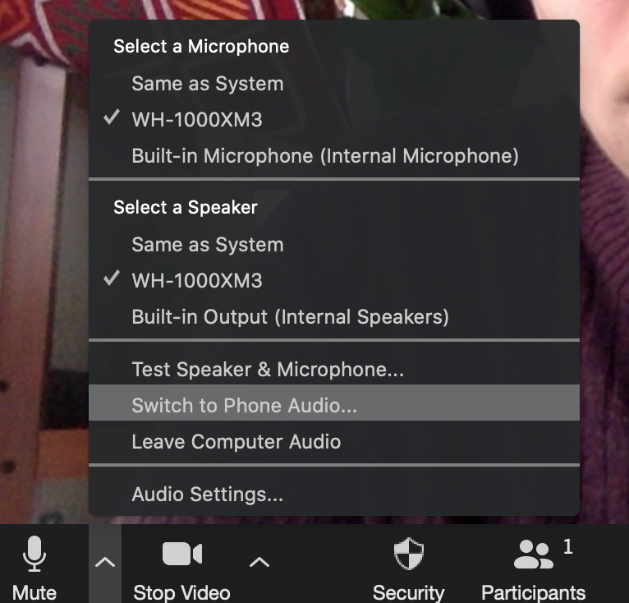
    - The Zoom phone number will be listed on the screen

  - If your Zoom is open on a smartphone
    - Disconnect from audio
    - Then select dial in to meeting
    - Several numbers to dial will appear

- Call into the meeting
- From the phone you plan to use the call interpreter, dial the any number listed
(may need to try multiple)
- Enter the meeting ID when prompted press # press # again
DO NOT enter the participant ID

  - If using Zoom on a computer, Admit your phone to the meeting, rename your phone as interpreter
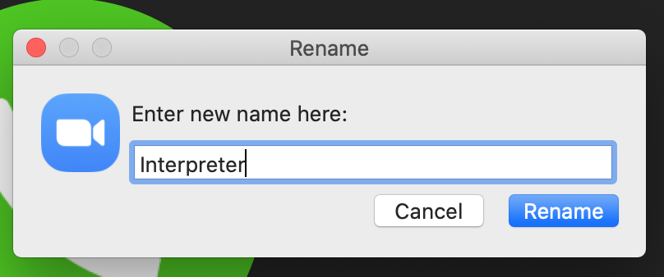
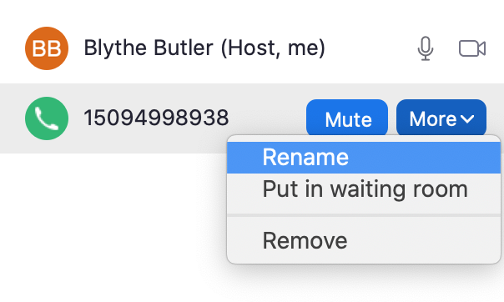
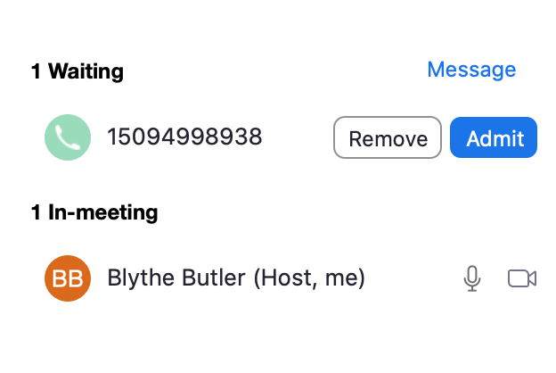

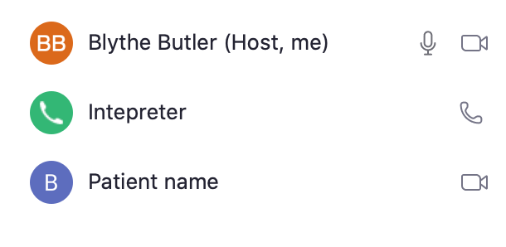
Doing this will show the interpreter as a separate participant in the meeting, which is helpful for the patient

⁺⁺Conference in interpreter services
- Add another line to the call dial interpreter services number
- Merge the calls
- If connected to device audio, mute your phone to avoid echo

Admit the patient to the meeting
- You should see yourself, interpreter line, and patient as participants
- Introduce the interpreter to the patient
- Conduct the visit

Questions or feedback on this tool? Please submit here: http://tiny.ucsf.edu/telemedsurvey

