Provider: Converting Telephone visits to Video Visits

**These instructions assume you have installed Zoom on your device and feel comfortable initiating a visit**
- If this is not the case, see the tip sheet on setting up your Zoom

OVERALL Workflow for converting from a phone visit to a telemedicine visit
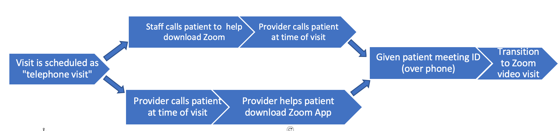

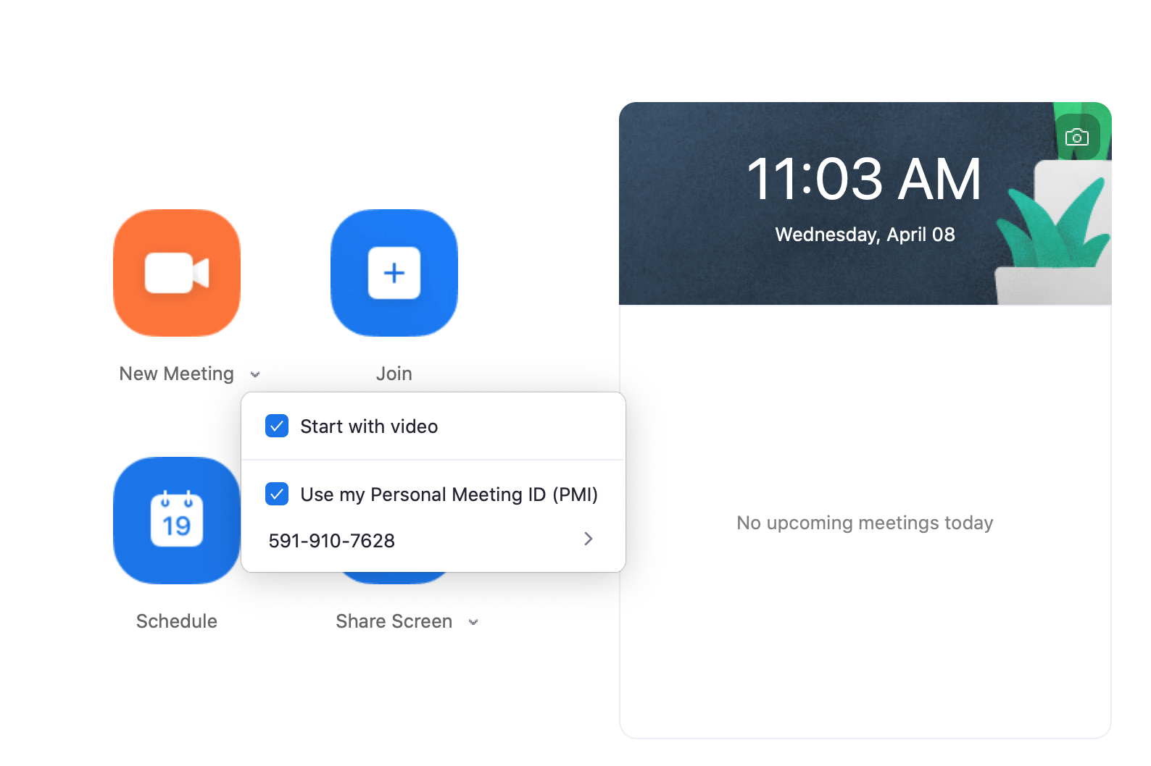
AT THE BEGINNING OF THE CLINIC DAY
- Make sure your Zoom settings are correct
  - Make sure “Personal Meeting ID” and “Waiting Room” features are enabled
  - Make sure you know your personal meeting ID
    - Open the Zoom app click the carrot next to “New Meeting” personal meeting ID listed here

BEFORE VISIT
- Check the visit type for the patient: If “Telephone”, consider offering video visit
- Check to see if patient has already downloaded and practiced with Zoom (clinic specific flow)

DURING THE TELEPHONE VISIT
- Call the patient at the indicated telephone visit time
  - Confirm the patient’s ID (full name and DOB)
  - For those with zoom downloaded:
    - “I see that you downloaded the zoom app, which means that we can do this visit by video. I would love the opportunity to interact face-to-face rather than just by phone; would you be open to that today?”

  - For those who do NOT have zoom already downloaded:
    - “We are starting to introduce video visits so that we can interact face-to-face rather than doing visit by phone. It would require you to downloading a video app on your phone or tablet, which takes 2 minutes. Would you be open to doing this now so we can do this visit by video?

    - Help them download the Zoom app

- If agrees to video visit:
  - Open the Zoom app on your desktop Click “New Meeting”
  - Say: “I’m going to give you a meeting ID to convert to a video visit. Can you open up the Zoom app now? (*wait for the patient to confirm app is open*) Please Click “Join a meeting” Enter (give your personal meeting ID) Click “Join” Click “Join with Video.” You should be in the waiting room. Let me know when you are"

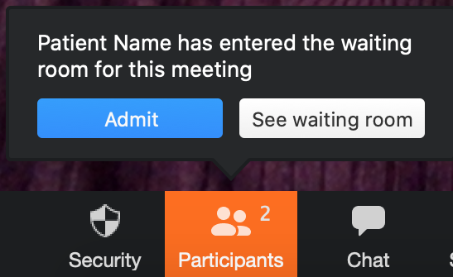
- Admit the patient to the video visit
  - If the Admit button is not visible, click “Participants.” The Waiting room will appear on the right of the screen.

  - If you can’t see the patient’s video, send the patient a prompt to turn on their video by clicking “Manage participants” More Ask to start video

AFTER THE VISIT
- Document consent

- What to document
- Chief complaint
- Patient history
- Assessment and plan
- Names and roles of visit participants
- DO NOT document physical exam elements that require physically touching the patient!

- Sign the encounter

Questions or feedback on this tool? Please submit here: http://tiny.ucsf.edu/telemedsurvey

