Setting up your Zoom Account for Telehealth video visits

The following are steps that will help you best set up a Zoom account for telehealth visits. You can set up your account through the Zoom web browser or through the Zoom desktop app.
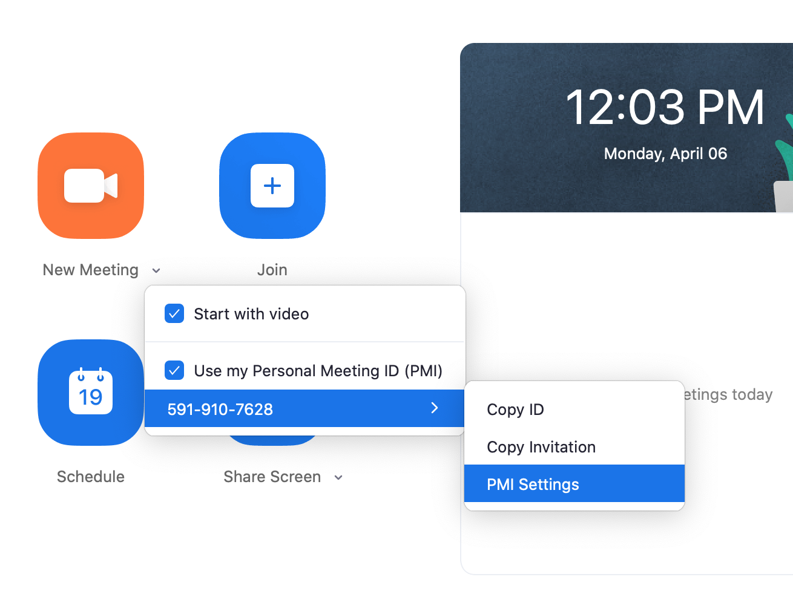
Option A: Zoom Desktop App (easiest)
Setting up Personal Meeting ID
- Open Zoom Desktop app
- Click the carrot next to “New Meeting”
- Click “Use personal meeting ID”: this enables the use of your personal meeting ID to give to patients

Setting up Waiting Room
- From Hover over PMI go to PMI settings
- Click on Advanced options click “Enable Waiting Room click “Save”
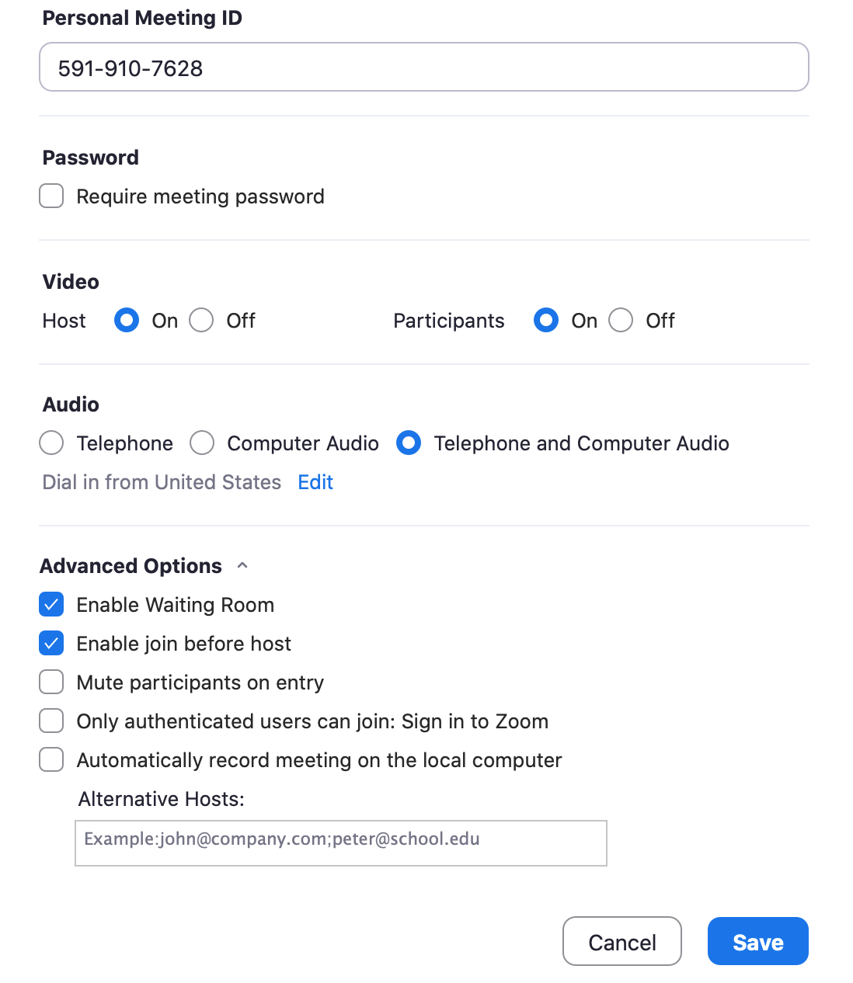
Option B: Zoom Web Browser
Go to Zoom profile page
- Go to https://zoom.us/signin
- Create account/Sign in with email and password

- Click on Profile on the left-hand side
- Go to Personal meeting ID
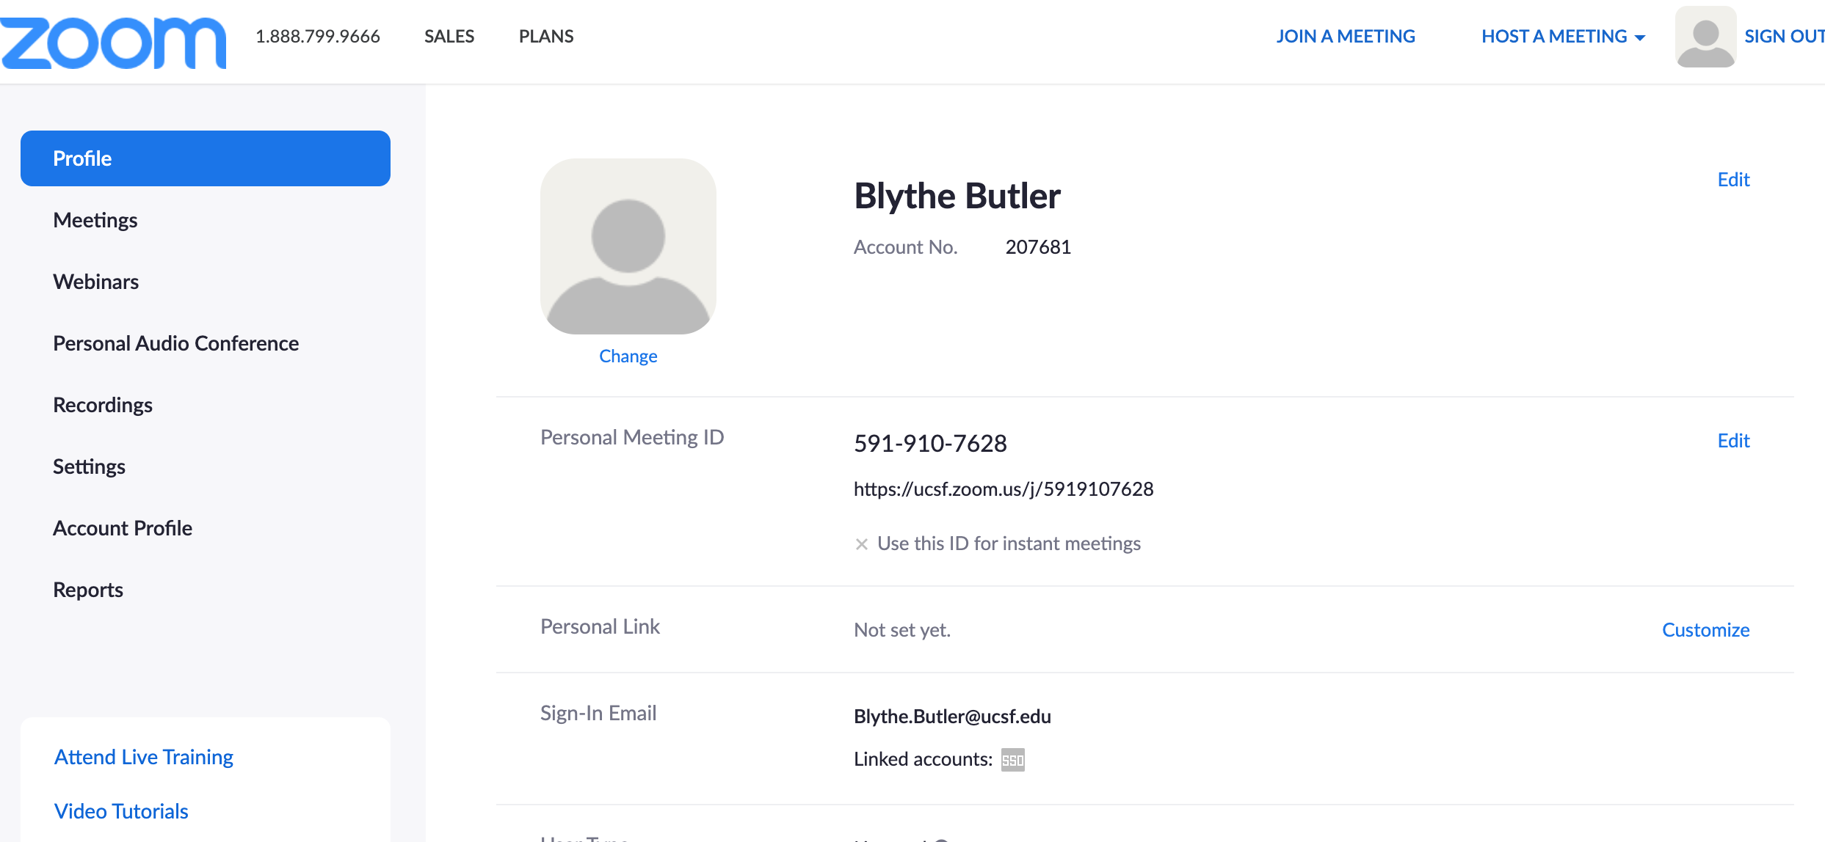
- Click on Edit on the far-right side.

- Check “Use Personal Meeting ID for instant meeting.”
- Click save changes
- Send this number to your clinic administrator who will be scheduling appointments

- Click on Settings on the left hand side
- Scroll down to In Meeting (Advanced) and find “Waiting Room”
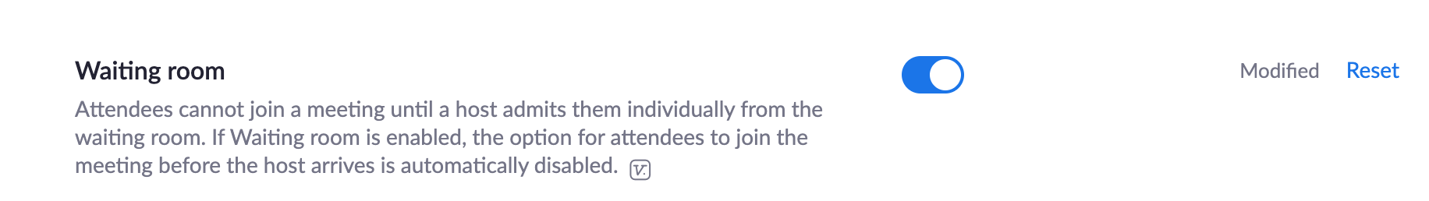
- Toggle “Waiting room” so it is blue

Questions or feedback on this tool? Please submit here: http://tiny.ucsf.edu/telemedsurvey

